Test Project

Server Side B

**Submitted by:**

WorldSkills International

Manuel Schaffner CH

**Competition Time:**

3 hours

**Assessment Browser:**

Google Chrome

## Introduction

WorldSkills International would like to create a web application to manage the reservation process for Restaurant Service during a WorldSkills Competition. This tool will be used to request reservations to participate in the Restaurant Service competition.

## Description of project and tasks

The overall application should suit the following requirements:

Bookings should be able to be done for an individual or a group. The look of the web application will correspond with the WorldSkills brand.

### Restaurant Service Seating information

There are four modules that each Restaurant Service Competitor has to perform during a lunch service throughout the Competition on a rotation basis. Therefore all four modules are done each day from C1 - C4 by different Restaurant Service Competitors, thus each Restaurant Service Competitor will compete every day and do one (different) module each day. This means that guests on the same day will have different dining experience options.

The 4 modules are:

* **Casual Dining** – 2 seating per day:  
  Seating 1 – 10:50am – 12:00pm  
  Seating 2 – 13:30pm – 14:40pm  
    
  Seating for each Restaurant Service Competitor in the following configuration:
  + - * 1 table of 4
      * 1 table of 2

Total guests required assuming 6 Restaurant Service Competitors would be 36 guests per seating/day.

* **Bar Service** – 1 seating per day:  
  Seating: 13:15pm – 14:45pm  
    
  Seating for each Restaurant Service Competitor in the following configuration:

1. 1 table of 6

Total guests required assuming 6 Restaurant Service Competitors would be 36 guests per seating/day

* **Fine Dining** – 1 seating per day:  
  Seating: 13:00pm – 15:15pm  
    
  Seating for each Restaurant Service Competitor in the following configuration:

1. 1 table of 4

Total guests required assuming 6 Restaurant Service Competitors would be 24 guests per seating/day.

* **Banquet Dining** – 1 seating per day:  
  Seating: 12:45pm – 15:00pm  
    
  Seating for each Restaurant Service Competitor in the following configuration::

1. 1 table of 6

Total guests required assuming 6 Restaurant Service Competitors would be 36 guests per seating/day.

The information for the competition days (eg “C1 – 04.08.2015”) and the seating (name, description of module, configuration eg. “1 table of 4 and 1 table of 2”, time eg “13:15pm – 14:45”, total number of Restaurant Service Competitors, number of seats/guests per Competitor) are to be configurable in the database (no need to create an interface; always four competition days and four Restaurant Service modules).

The system shows the number of seats available (at the point of time when the page is called) for each of the seatings. It is possible to request a booking for a full seating.

The maximum guests from the same country for one seating is the total number of seats for that seating minus the seats served by one Restaurant Service Competitor (in the example above that would be maximum 30 guests from one country for one seating of “Casual dining”). This is to make sure that no guests will sit at the table where the Restaurant Service Competitor is from the same country as the guests. The maximum number of guests is the same for any country, even if that country does not have a Restaurant Service Competitor.

The system always accepts booking requests for any of the four competition days. Requests for past days will not be considered by WSI staff and will be declined. Bookings requested that exceed already confirmed seatings can be waitlisted in the case of a cancellation. The guest should be notified that they are on a waitlist and that they will be called if a cancellation occurs.

### Workflow

Submitted requests will automatically be scheduled into the overall schedule, but must be confirmed by WSI staff. WSI staff need to have the option to reschedule bookings (per guest) for other days, times or dining types. Once bookings are confirmed, the requester will receive an official email confirming their schedule.

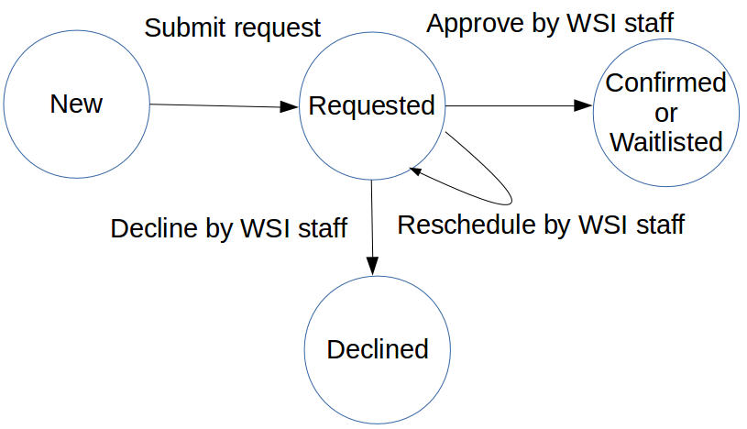

Figure 1: Reservation states

### Pages required

* Homepage with dining experience descriptions
* Booking Contact Details and Guest Regulations
* Booking Request for:
  + Individuals
  + Groups
* Submission Confirmation
* Reservation Management

Each of the pages and its behaviour is described below.

### *Homepage with Dining Experience descriptions*

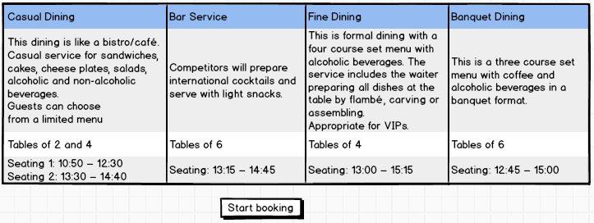

The homepage will give a brief overview of each dining experience.

### *Booking Contact Details AND Guest Regulations*

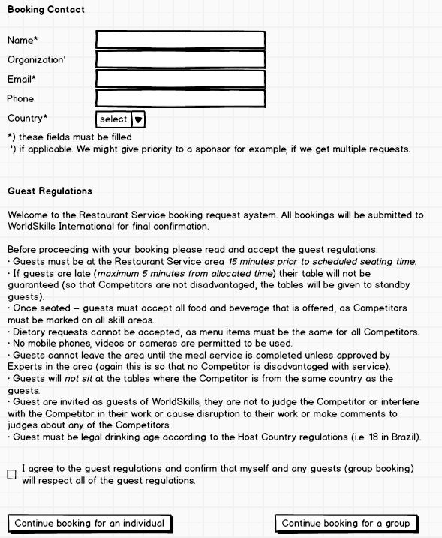

Everyone must accept the guest regulations before proceeding.

The mandatory fields must be verified and the email must be checked for correct pattern (eg. xxx@yyy.zzz).

For an individual, its name and country will also be used as guest information.

The list of countries is static and provided in the HTML code.

### *Booking Request*

### *Individual*

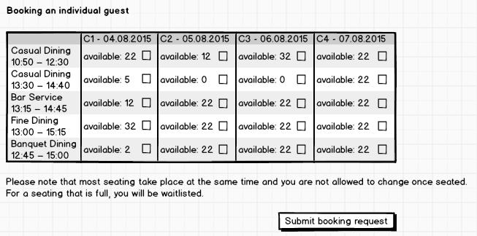

Individuals may select more than one seating. Guests will be waitlisted for seating that are full.

### *Group*

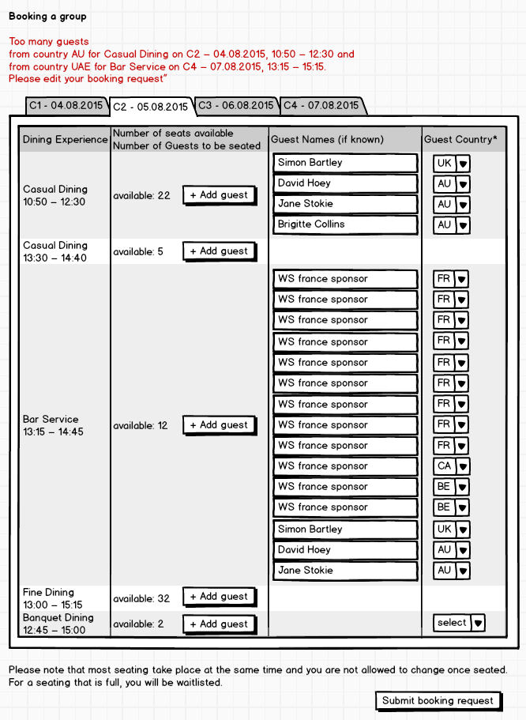

The booking contact (no booking request for a seat) may enter information about the guests they want to request bookings for. They must select the day, dining experience and number of guests for each seating - that will add/remove the respective number of lines/input fields for that seating. Guest must be identified by their country at a minimum.

After submitting (pressing the button), the number of requests for guests from the same country per seating will be verified (server side). If there are too many, the booking page containing all the data will be displayed again, together with a message informing the booking contact to correct the request (see above). Only when correct it will be submitted to the database and continue to the confirmation page.

### *Submission Confirmation*

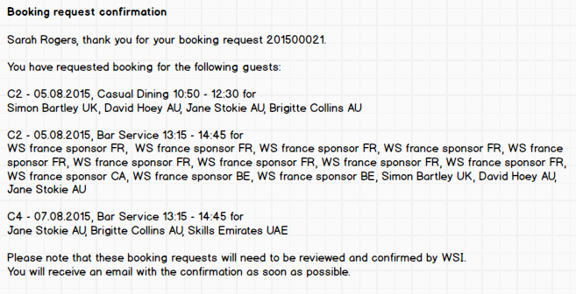

Upon submitting their requests there should be a confirmation of their submission *on screen*. A text informs them to wait for the reservation confirmation via email.

### *Reservation Management*

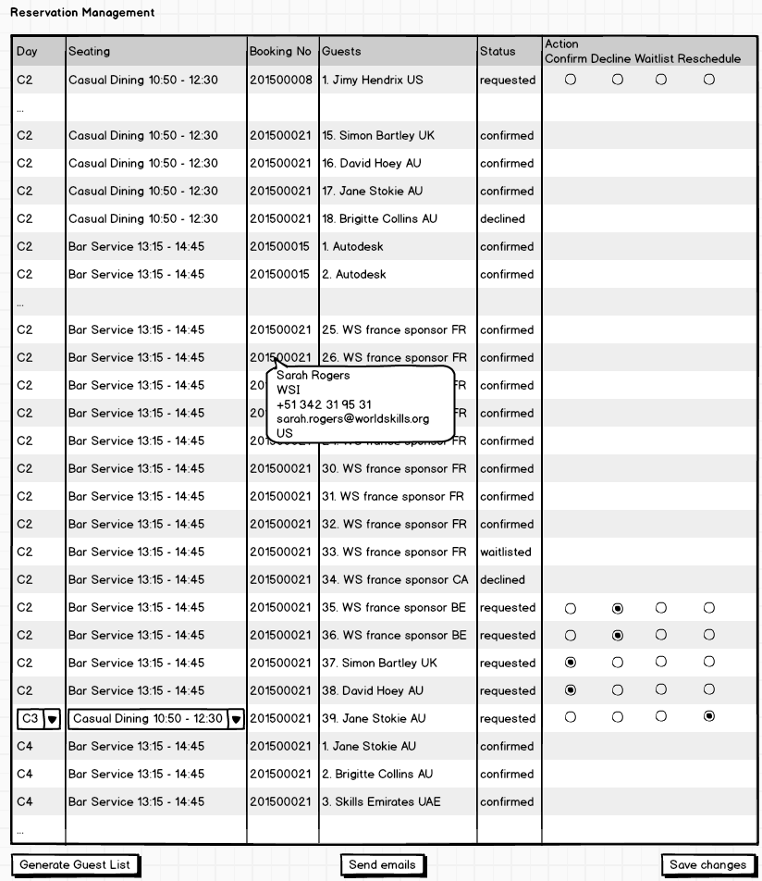

In a separate directory called “/management” inside the module directory (protecting this directory e.g. by .htaccess is not required and **not** part of the competition) provide a page called “ReservationManagement.php” where WSI staff can view all existing reservations and confirm (accept), waitlist or decline pending reservations by selecting the respective radio button (shown only for “requested” state) per entry. It is not necessary to select a radio button for each line – the entry can be left undecided for later.

Pending (“requested” state) reservations can also be rescheduled to a different seating on the same or a different day: marking the entry for rescheduling will show the dropdowns for selecting the day and seating after saving (see above). Then the WSI staff can select the appropriate day and seating, set the entry to “confirm” and save.

The list is sorted by day, then seating, then booking status (1. Confirmed, 2. Requested, 3. Waitlisted, 4. Declined) and then booking no (sequence of booking). The requests per seating are numbered (number preceding the name of guest). In that way it is easy for WSI staff to see how many guests they can allow (see “Bar Service” above).

“Send emails” will send a note to each booking contact, showing the status of booking for every guest Pressing the button multiple times will send multiple notes to the same contact unless every guest for that contact is either confirmed or declined. ***For the competition “Send emails” will just save a text-file with the specified information on the server in a directory “/emails”.*** Later that will be changed into sending out an email.

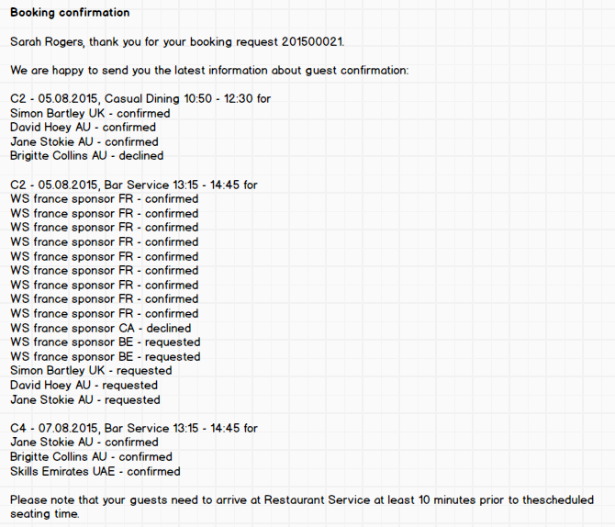

### *Export for Restaurant Service Host*

Booking information must be able to be exported or viewable (csv or screen) by the Restaurant Service host/hostess so they can seat people at the appropriate table (i.e. ensure that no one sits at a table with a Competitor from their country). This can be done using the button “Generate Guest List”.

Host/Hostess should clearly see the following information for each guest, grouped by day, then by seating, sorted by Booking No and filtered by status “confirmed”:

* Booking No
* Booking Contact Name
* Booking Contact Organization
* Guest Name
* Guest Country

## Instructions to the Web Design Competitor

## Save your files in your working directory on the server called "XX_ServerSide_B ", where XX is your country code.

## It should be possible to start the application by calling the directory mentioned above. You might need to create some kind of redirect to the applications main page.

## Create/generate a DB-diagram named “db-diagram.xxx” (xxx is the extension/type of the file eg. pdf or jpg) and put it into the directory mentioned above. You can use phpmyadmin -> designer or any other tool to generate the diagram. Example:

## Save all your work files (those that will *not* be assessed) into a subdirectory called “work”.

## Save all other files (those that will be assessed) into a suitable directory structure and naming inside the directory mentioned above.

* Create a SQL dump of your database and put the *.sql file in a folder “/dbdump” inside the directory mentioned above (XX_ServerSide_B).

## For this module you must use one of the two available frameworks which you installed on familiarization-day (C-2). Applications developed without use of any of these frameworks will not be considered. You should take advantage of the framework as much as possible.

## Files PROVIDED

|  |  |
| --- | --- |
| **Item** | **Description** |
| Laravel PHP Framework incl. short documentation / cheat sheet | Web Design Competitor can choose which one of these frameworks he wants to use. Installation will be done on the familiarization-day (C-2) |
| Yii PHP Framework incl. short documentation / | Web Design Competitor can choose which one of these frameworks he wants to use. Installation will be done on the familiarization-day (C-2) |
| WSC2015_TP17_ServerSide_B_media_template.zip | Media files to be used |

**Internet Access**

* no internet access

## Marking Scheme SUMMARY

|  |  |  |  |  |
| --- | --- | --- | --- | --- |
| **SECTION** | **CRITERION** | **judgement marks** | **Objective marks** | **TOTAL** |
| H1 | Functionality: Dining Descriptions & Booking Contact |  | 1.25 | 1.25 |
| H2 | Functionality: Booking Request for Individual |  | 1.25 | 1.25 |
| H3 | Functionality: Booking Request for Group |  | 1 | 1 |
| H4 | Functionality: Reservation Management |  | 2.5 | 2.5 |
| H5 | Functionality: Submission Confirmation and Reservation Confirmation |  | 1.25 | 1.25 |
| H6 | Functionality: Reservation Data Export |  | 1.25 | 1.25 |
| H7 | Functionality: Interaction / Workflow | 0.5 |  | 0.5 |
| H8 | Working with Libraries | 4 |  | 4 |
| H9 | Data & Structure | 1 | 1 | 2 |
| **Total** |  | **5.5** | **9.5** | **15** |